TO LOAD EXCCEL SHEET FROM BLOB TO GEN 2

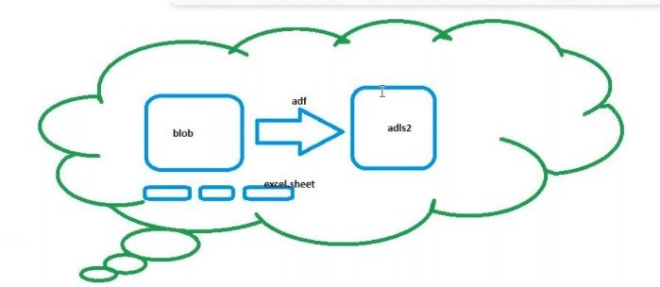
Create a container in a blob and upload the employee excel sheet
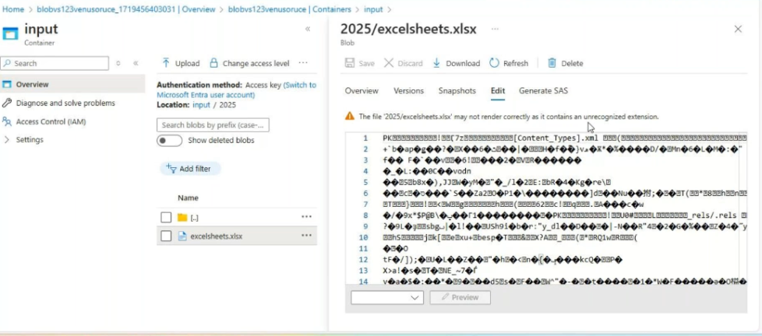

Create a gen2 storage create a container
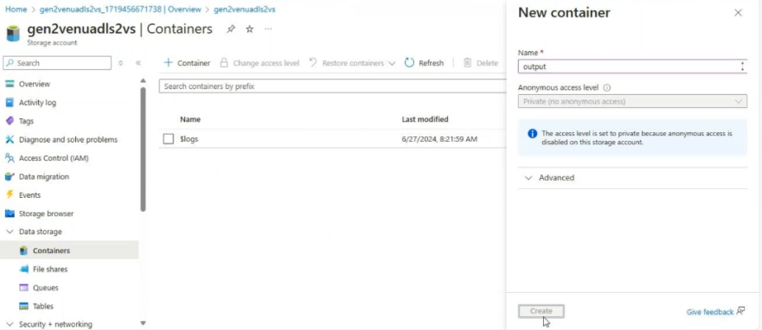
Create a integration runtime
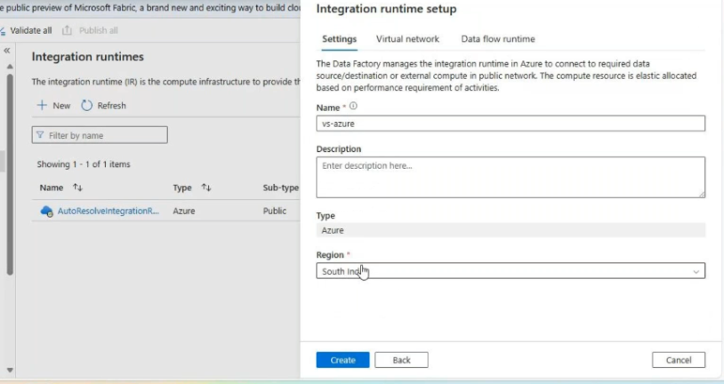
Create a source_linked services by using this azure ir
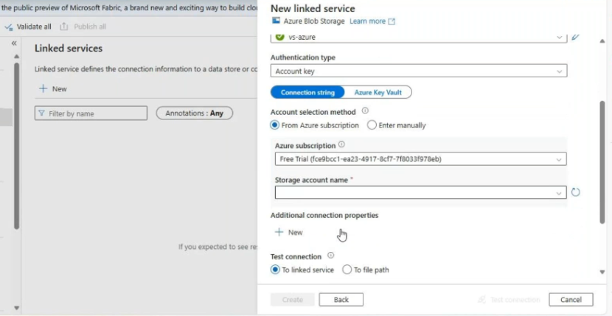
Create sink_side lk by using this ir
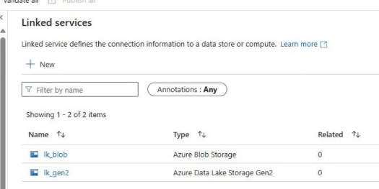

Create a source data set
Tanking blobexcel sheet
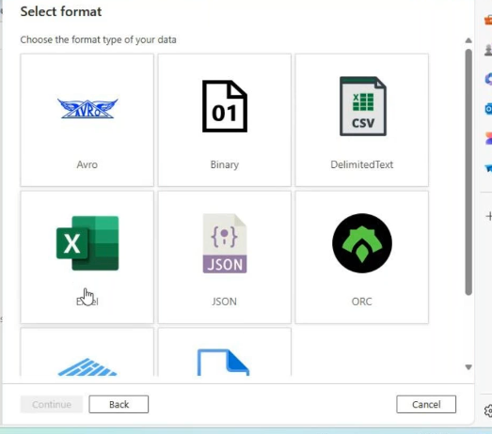
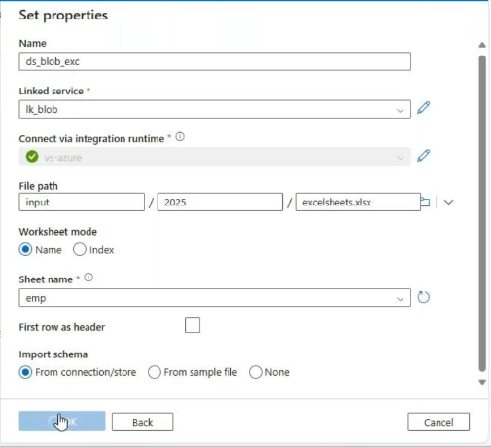

Creating sink_side dataset taking gen2take csv fle
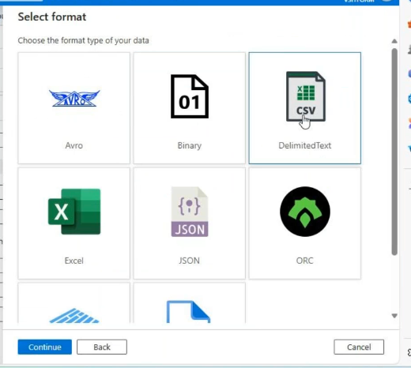
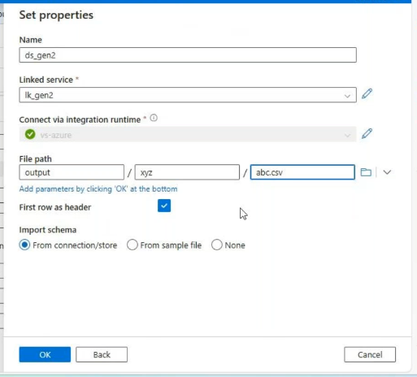
Create a pipeline and name it
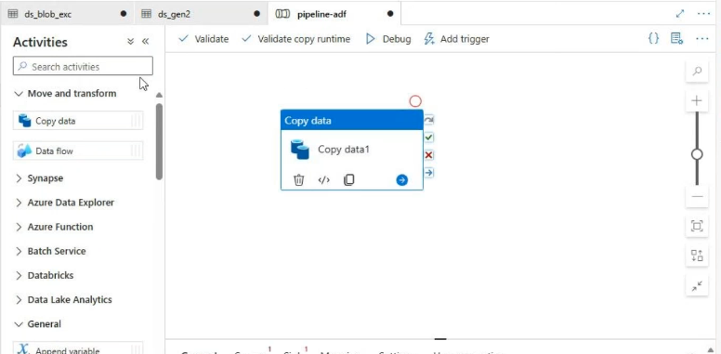
Source_side:
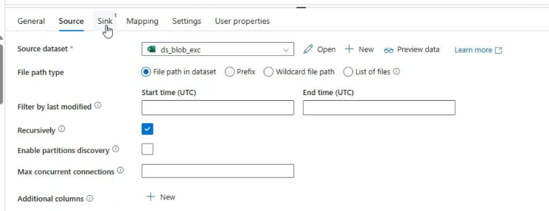

Sink_side:
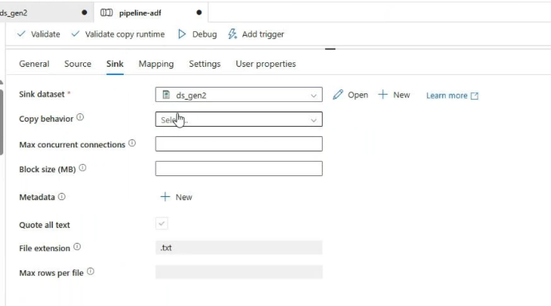
Validatedebug
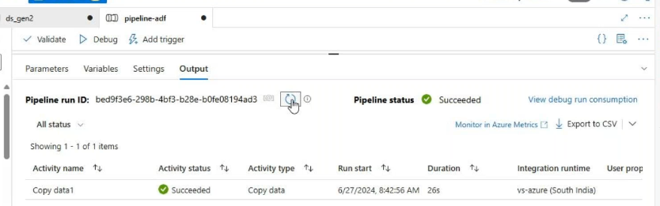
Output:
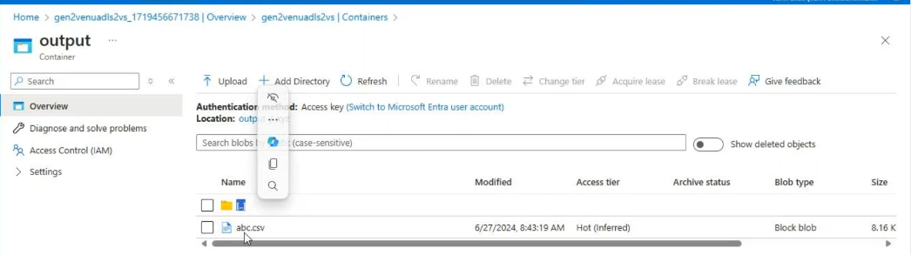
Download the csv file
Upload In to the blob storage
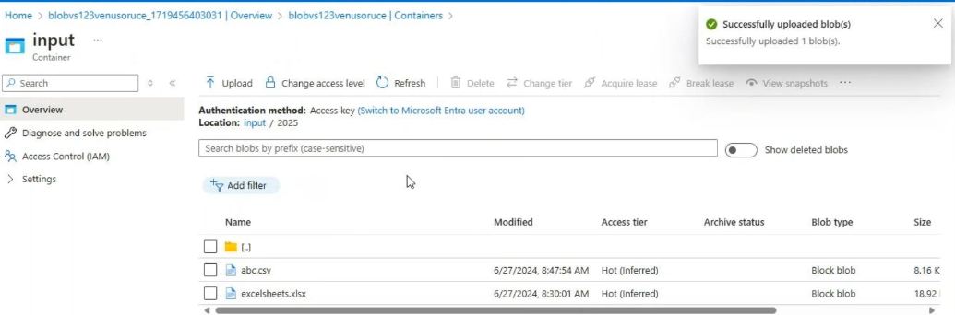
Create a new dataset for source_side for this source is blob here and take csv file
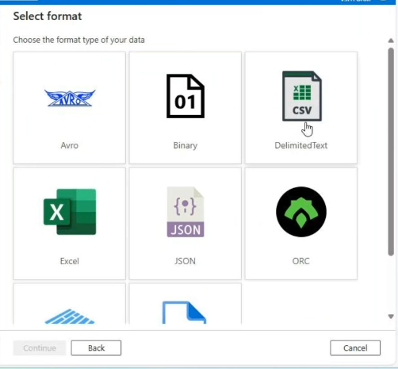
Here you need to select csv file only
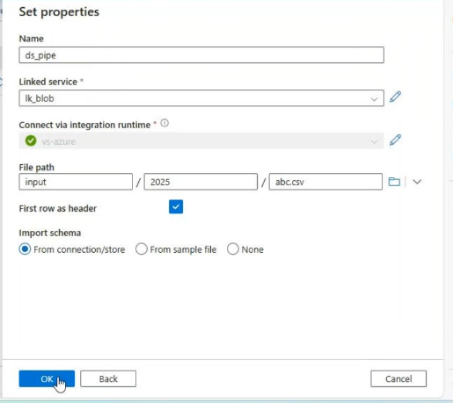

Create a new dataset for sink side take gen2 csv file
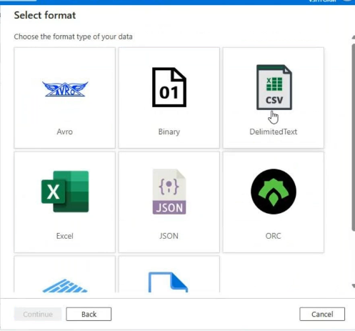
We need to write file name
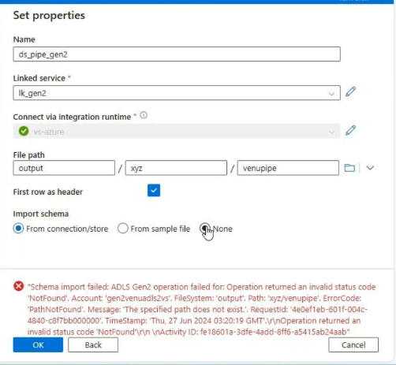
Open this dataset :
Change the column delimiter comma to pipe symbol
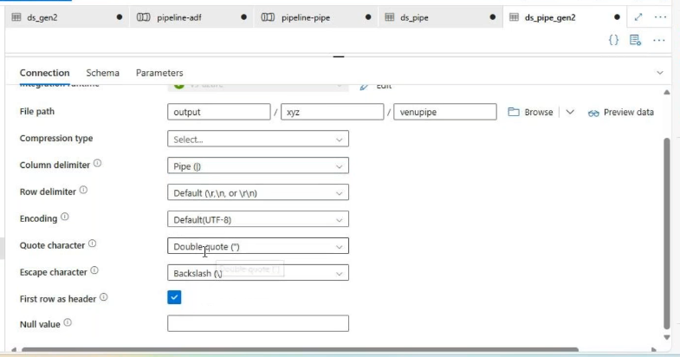
Create a new pipelinecopy dataactiity
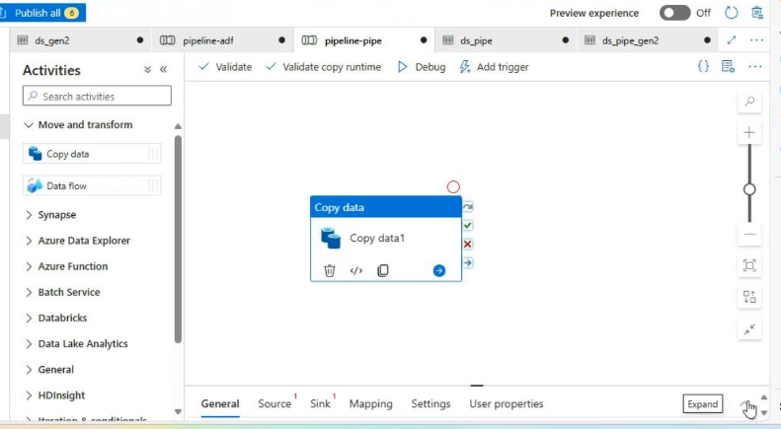
In copy data activity source_side:
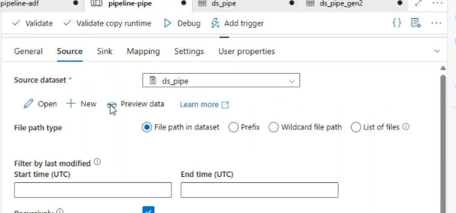
In copy data activity sink_side:
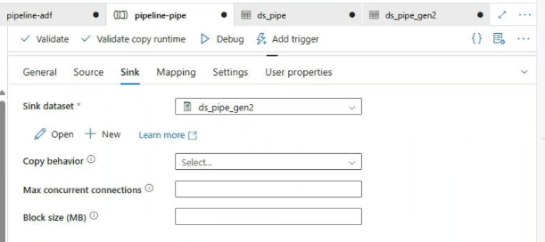
Validatedebbug
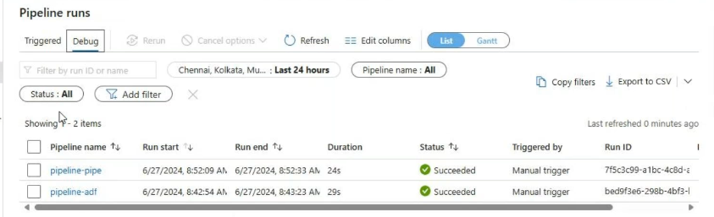
Output:
